Statistics HW4 b03705002林軒逸

4.9 a

Mean=(-0.15)+(-0.2)+0.15+(-0.08)+(0.5)/5 = 0.044

Median->(5+1)/2=3-> Take the third rate. = -0.08

4.9b

{[1+(-0.15)]\*[1+(-0.2)]\*[1+0.15]\*[1+(-0.08)]\*(1+0.5)}^1/5 -1

= 1.0154 -1 =0.0154 (1.54%)

4.9c

Geometric mean. Due to reality, the rate isn’t independent to one another. Thus, we should use geometric mean to get close to the reality.

4.13

Mean: 11.185

Median: 11

By the mean and median, we can see that median and the mean of these customers differ. The median is 11, and the average is approximately 11, too. This means that the mean and median in this case is close, and the histogram’s shape of it might be symmetrical and unimodal.

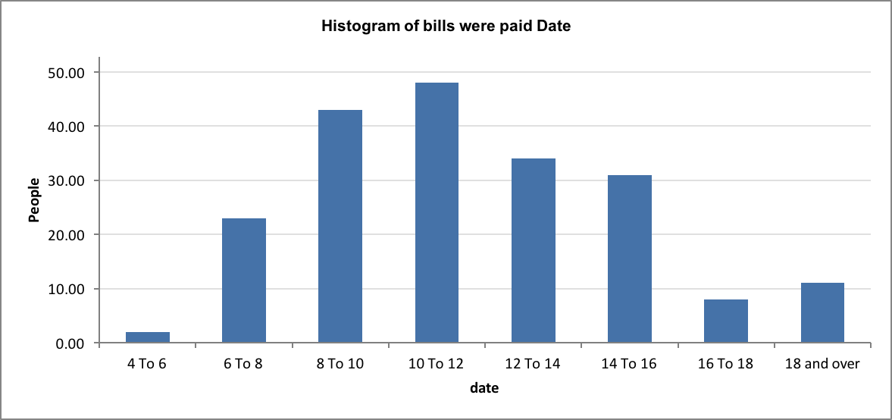

4.17a

Mean: 32.90833

Mode: 32

Median: 32

4.17b

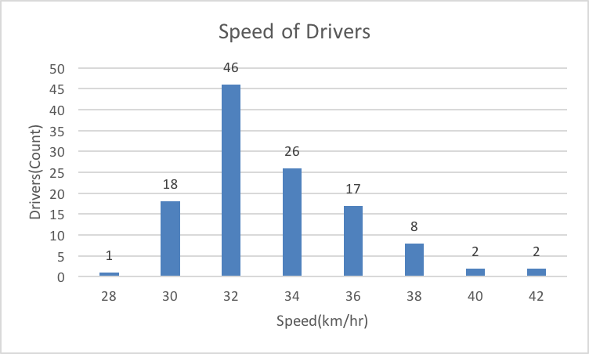

By observation, we can say that the median, and mode of the speed are almost the same. However, the mean of it is quite bigger than the mode and the median. That is, the graph has the highest peak on 32, same as where the median and the mean stand, and the histogram of is a little right-skewed.

4.29a

Using Chebyshaff’s law:

K=2-> 1-1/4= 3/4 (0.75)

At least 75% of observation.

4.29b

Using Chebyshaff’s law:

K=3 ->1-1/9= 8/9(88.9%)

At least 88.9% of observation.

4.35

Average: 175.7333

Standard Deviation: 62.06303

We can see that the standard deviation is not very big. That is, the data is quite is quite focus. Although it’s not bell-shaped, but we can see that if we uses the Empirical law, in one standard deviation of mean (approximately 113 to 237), there is definitely 68% of the data. Also, it obeys the Chebyshaff’s law, too.

In conclusion, although the graph isn’t bell-shaped at all, but it is quite focus, and the mode of the graph lies in 150-200.

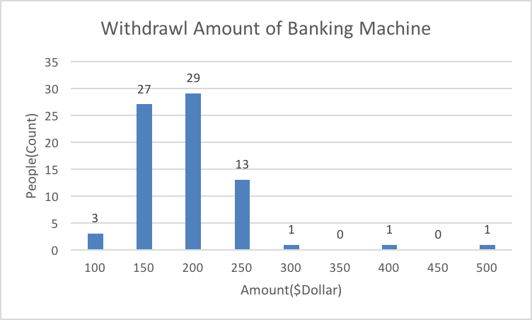

4.39 a

Mean: 23.40223

Variance: 384.0957

Standard Deviation: 19.59836

4.39 b

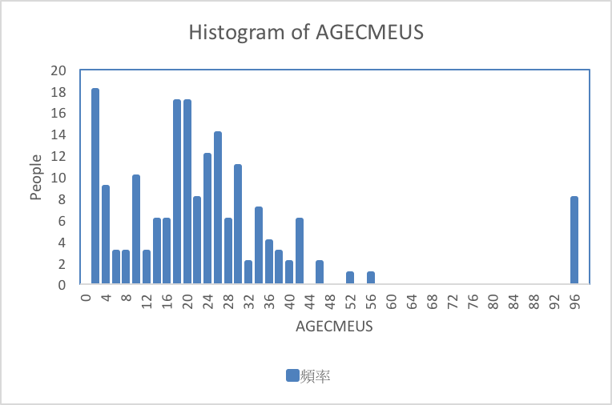

4.39 c

By the histogram, we can easily observe that it isn’t bell-shaped. Thus, Empirical Rule can’t be applied. Thus, we use Chebysheff’s law instead.

When K=2, that is, -15.8 to 62.6, at least 75% of the area will be covered.

When K=3, that is, -35.4 to 82.2, at least 88.9 of the area will be covered.